DPL LOGO HERE

ROCKSAT-XN

SPARK

Assembly Instructions

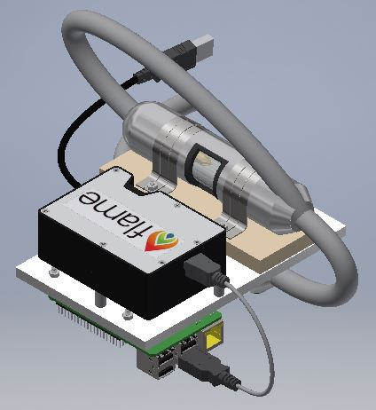

Contents

I Acronyms

II Parts List

III Vendors/Suppliers

IV Transformer Assembly

V Spark Gap Assembly

VI Final Assembly

VII Shop Drawings

VIII Manufacturing

IX Testing

X General Notes

Part I

Acronyms

DPL Dusty Plasma Lab

MMC McMaster Carr

UMBC University of Maryland Baltimore County

Part II

Parts List

|  |  |  |  |  |  |
| --- | --- | --- | --- | --- | --- |
| Part | Supplier | Supplier  ID # | DPLX  Part # | Quantity | Assembly Parent |
| M3X.5mm  SS Hex Nut | MMC | 91828A211 | NA | 8 | 4-Spark Gap  4-Transformer |
| M3X.5mm  SS Phillips Flat Head  12mm | MMC | 92010A122 | NA | 8 | 4-Spark Gap  4-Transformer |
| M3X.5mm  SS Phillips Flat Head  14mm | MMC | 92010A787 | NA | 14 | 8-Spark Gap  6-Transformer |
| Steel Clamp | MMC | 9429T360 | NA | 4 | 2-Spark Gap  2-Transformer |
| Aluminum  Foil Wrap | Giant | NA | P015 | 1 | Spark Gap |
| Baffle  Inner | Keith Porter Imaging Facility | NA | P003 | 2 | Spark Gap |
| Baffle  Outer | Keith Porter Imaging Facility | NA | P004 | 2 | Spark Gap |
| Electrode | UMBC Mechanical Engineering Dept. |  | P001 | 2 | Spark Gap |
| Electrode  Set Screw | UMBC Mechanical Engineering Dept. |  | P006 | 2 | Spark Gap |
| Ferrite Choke |  |  | NA | 2 | Transformer |
| Quartz Tube | GREATGLAS, Inc. |  | P025 | 1 | Spark Gap |
| Spark Gap Shielding Top |  |  | P029 | 1 | Spark Gap |
| Spark Gap Shielding Middle |  |  | P028 | 1 | Spark Gap |
| Spark Gap Shielding Bottom |  |  | P027 | 1 | Spark Gap |
| Transformer |  |  | P026 | 1 | Transformer |
| VIPE Shielding Top |  |  | P031 | 1 | Transformer |
| VIPE Shielding Middle |  |  | P032 | 1 | Transformer |
| VIPE Shielding Bottom |  |  | P030 | 1 | Transformer |
| Viton Insulation |  |  | P033 | 1 | Spark Gap |
| Viton Insulation |  |  | P034 | 1 | Transformer |
| Wire Shielding | Electriduct |  | NA | 1 | Spark Gap  Transformer |
| Lab Base Plate Small PV | UMBC Mechanical Engineering Dept. | NA | P014 | 1 | Base Plate |
| Raspberry Pi Standoffs  Delrin | MMC |  | P021 | 4 | Final Assembly |
| Ocean Optics Standoffs  Delrin | MMC |  | P017 | 3 | Final Assembly |

Part III

Vendors/Suppliers

* MSC Direct Industrial Company

https://www.mscdirect.com/

* McMaster-Carr Supply Company

https://www.mcmaster.com/

* Formlabs Inc.

<https://formlabs.com/>

* Keith Porter Imaging Facility

<https://kpif.umbc.edu/>

* UMBC Mechanical Engineering Dept.

<https://me.umbc.edu/>

* GREATGLAS, Inc.

<http://www.greatglas.com/>

* Electriduct

https://www.electriduct.com/

Part IV

Transformer Assembly

Step1

* Assemble the G10 shielding
* Insert -92010A122 M3 12mm Screws into the VIPE Insulation Middle Part
* Insert -92010A787 M3 14mm Screws into the VIPE Insulation Middle Part
* 12mm screws face up and will be used to fasten 2 clamps. The 14mm screws will be used to connect this piece to the baseplate.
* 12mm Screws are shown in the top and bottom of the picture 14mm are in the center

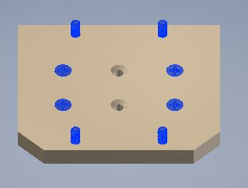

* These screws must be flush with the surface of the insulating plate, otherwise the assembly could become misshapen.

Step 2

* Install the VIPE Insulation Bottom
* Insert the VIPE Insulation Bottom over the 4 screws that are on the bottom of the VIPE Insulation Middle.

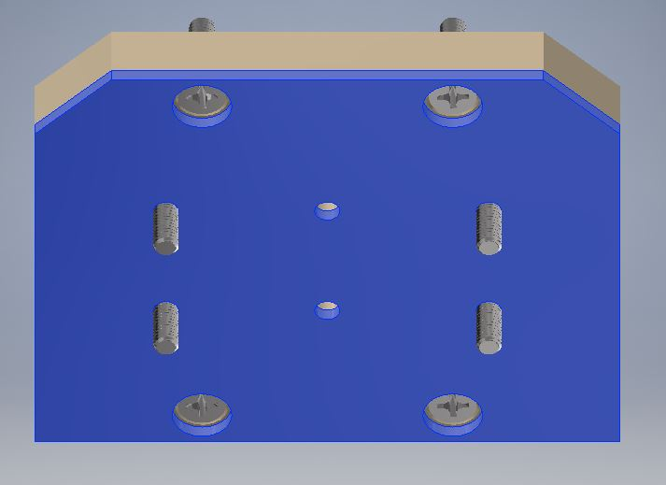

Step 3

* Install the Shielding plates to your mounting surface.
* The baseplate we used for flight had tapped holes and our lab test model had recesses for nuts. Either method is will work for assembly.
* If you are using recesses to allow for your bolts as shown in the image below it is important to know the transformer and the spark gap are on opposite sides of the plate and you need to install the transformer first.
* Attach the 4 screws that pass through the shielding material to your baseplate using one of the two methods explained above. There should be no part of the screw that extends out from the baseplate on the opposite side.

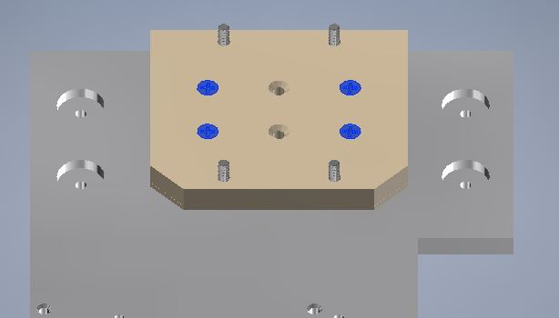

Step 4

* Install the VIPE Shielding Top.
* Place the VIPE Shielding Top over the four screws and set this assembly aside in a safe area.

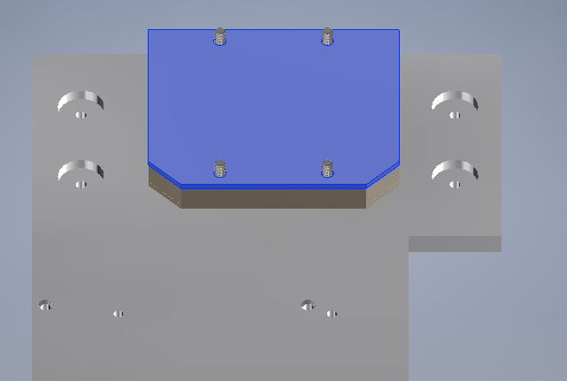

Step 5

* Wiring the transformer
* Connect two wires to both ends of the transformer making sure the step up in voltage is going in the correct direction for the transformer you are using.
* These wires should be around 3” long or long enough for you to comfortably solder them to another wire.
* You will have a total of four wires soldered to the transformer now.

Step 6

* Wrap the transformer in .125” Viton
* Wrapping the transformer in wire mesh shielding
* Cut a 6”-7” length of the wire mesh shielding.
* Insert the Transformer into the mesh shielding making sure about 1.5” hangs over each end of the Transformer.

Step 7

* Fastening the transformer to the G10 shielding.
* Center the transformer on the G10 shielding and using 4- 91828A211 M3 hex nuts and two clamps fasten the transformer to the shielding.

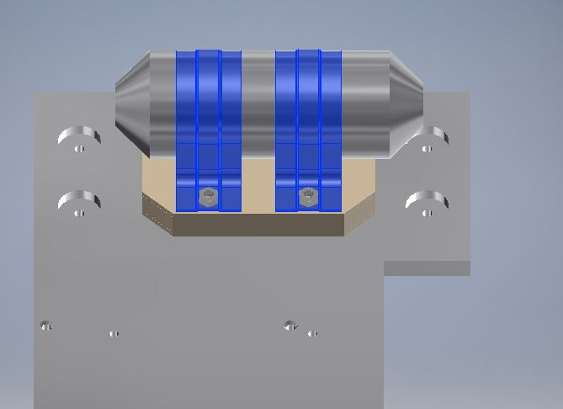

Part V

Spark Gap Assembly

Step 1

* Assemble the G10 Shielding
* Insert 4-92010A787 M3 14mm Screws into the Spark Gap Insulation Middle Part
* Insert 4-92010A122 M3 12mm Screws into the Spark Gap Insulation Middle Part
* 12mm screws face up and will be used to fasten 2 clamps. The 14mm screws will be used to connect this piece to the baseplate
* Outer screws are 12mm Inner screws are 14mm

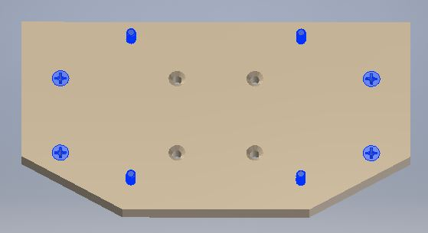

* These screws must be flush with the surface of the insulating plate, otherwise the assembly could become deformed.

Step 2

* Install the Spark Gap Insulation Bottom
* Insert the Spark Gap Insulation Bottom over the 8 screws that are on the bottom of the Spark Gap Insulation Middle.

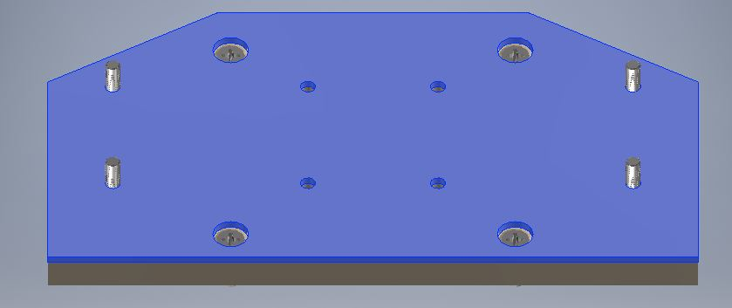

* The Spark Gap Shielding Bottom should fit over the screws easily. If this piece forces any of the screws to not be perpendicular to the plate, then the rest of the installation will be difficult.

Step 3

* Install the Shielding plates to your mounting surface.
* The baseplate we used for flight had tapped holes and our lab test model had recesses for nuts. Either method is will work for assembly.
* Attach the 4 screws that pass through the shielding material to your baseplate using one of the two methods explained above. There should be no part of the screw that extends out from the baseplate on the opposite side.

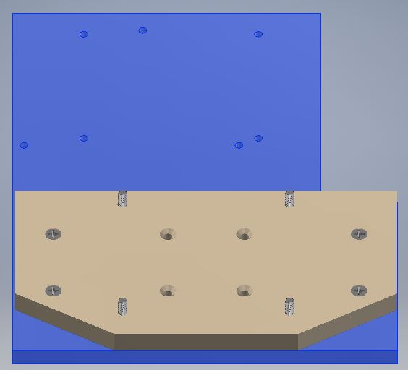

Step 4

* Install the Spark Gap Shielding Top.
* Place the Spark Gap Shielding Top over the four screws and set this assembly aside in a safe area.

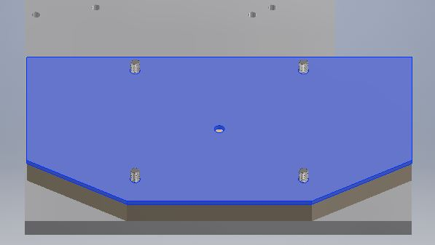

* The Spark Gap needs to be built at this point.
* Ensure that the insulation layers do not hit any of the screws and push them to an odd angle.
* The clamps used to secure the Spark Gap are fastened using the four screws sticking out of the top of the G10 shielding plates and need to be in the correct position to make the clamp installation easy.

Step 5

* Building the electrode assembly
* Gather the 2 electrodes, 2 inner baffles and 21 outer baffles.
* Insert the electrode into the inner baffle. The large ring section of the electrode should be towards the front of the inner baffle as shown in the picture.

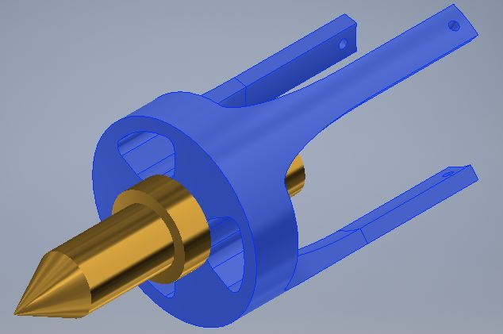

Step 6

* Now connect the two wires that will go to the transformer to the two electrode assemblies by inserting them through the center of the outer baffle and inserting it into the back recess of the electrode. The wire should be ran through the set screw hole (Red Arrow) of the electrode and through the center of the set screw.

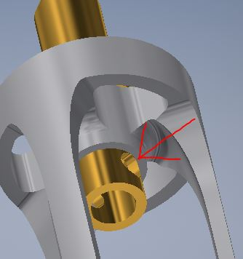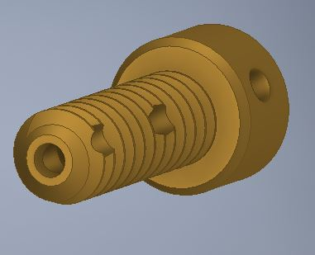

Step 7

* Install set screw with wire inside
* Connecting the baffles
* Insert the outer inner baffle and electrode into the outer baffle. The three prongs of the inner baffle line up with holes in the outer baffle. The holes in the pongs of the inner baffle should be visible on the opposite face of the outer baffle.
* Run thin wire through the small holes in the inner baffle to hold the assembly together
* Solder the wire to the set screw at the screw head.

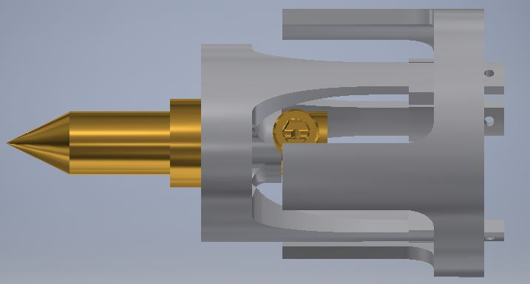

Step 8

* Wrap Quartz Tube in aluminum foil and .0625” Viton.
* Take a small piece of aluminum foil make sure it is flat and completely wrap the quartz tube leaving the ends open.
* Once the foil wrap is on the tube wrap the Viton around the tube. The Viton should have the view window precut. You can use electrical tape to hold the Viton together around the tube. Now remove the foil from the viewing window.

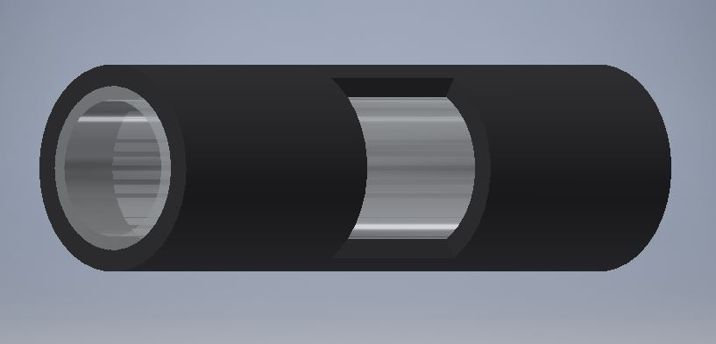

Step 9

* Install the electrode assemblies into the quartz tube.
* Insert the electrode assembly into the quart tube until the inner baffle is flush with the end of the quartz tube.
* The outer baffle prongs should go on the outside of the quartz tube and on the inside of the Viton.
* Be careful not to damage the foil wrap inside the Viton. This is difficult to accomplish but will increase the shielding of the spark gap.

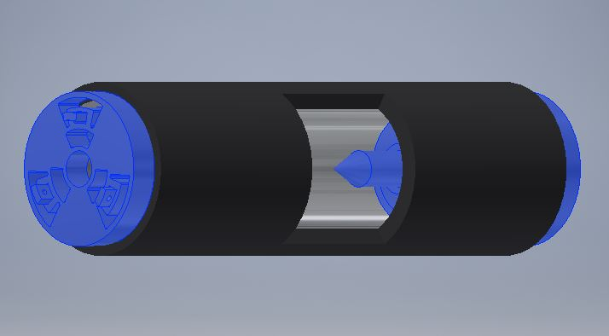

Step 10

* Wrapping the Spark Gap in Mesh Shielding
* Cut a 6”-7” length of the wire mesh shielding.
* Insert the Spark Gap Assembly into the mesh shielding making sure about 1.5” hangs over each end of the Spark Gap.

Step 11

* Mounting the Spark Gap to the G10 shielding
* Place the Spark Gap you just assembled and place it on the G10 Shielding assembly completed in Step 4.
* Make sure the viewing window is facing the direction of the rest of the payload and parallel to the baseplate and pointing towards the spectroscopy device.
* Place 2 clamps over the Spark Gap. They should fit over the four screws sticking out of the shielding.
* Using 4 91828A211 M3 hex nuts, install the clamps. The clamps should have a very snug fit and the Spark Gap should not move when the nuts are fully tightened.
* The images below do not show the wires attached in prior steps just the orientation of the Spark Gap on the base plate.

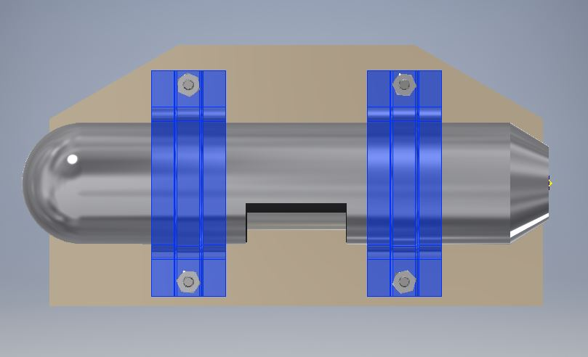

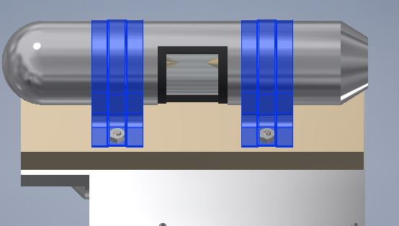

Note:

If you are using our test payload plate at this point in the assembly the payload should look similar to this.

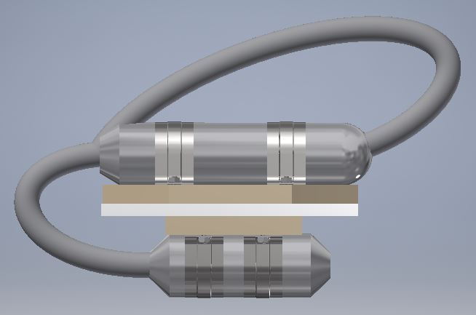

Step 12

* Wiring the transformer and the spark gap together.
* Install ferrite chokes on both sides of the transformer.
* Before connecting the wires between the transformer and the spark gap cut a length of the wire mesh shielding long enough to cover the wires between the two devices and slide it over the end of the wires of the transformer.
* Solder together the two leads from the spark gap to the two leads of the transformer making sure the transformer steps up the voltage to the spark gap.
* Extend the wire mesh shielding to cove the wiring.

Part VI

Final Assembly

Step 1

* Using four .25” Delrin standoffs, four 92000A111 M2.5 20mm SS screws, four 92141A004 washers and four 91828A113 M2.5 hex nuts install the Raspberry Pi on the base plate on the same side as the transformer.

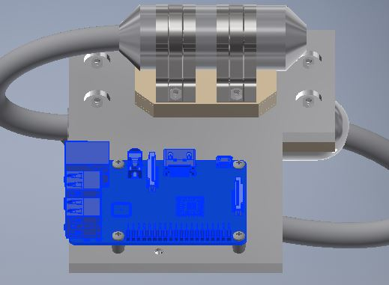

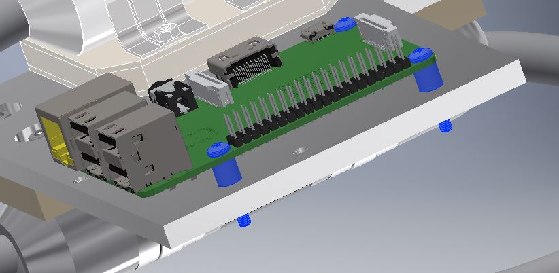

Step 2

* Install the Ocean Optic Spectroscopy Instrument
* Using the remaining 3 Delrin standoffs, three 91771A085 2-56 7/8” SS screws install the Ocean Optic Spectroscopy Instrument on the same side as the Spark Gap.
* The viewing window of the Spark Gap should line up with the camera of the Ocean Optic Spectroscopy Instrument.

Note: It is very important that the two components line up properly to get accurate readings.

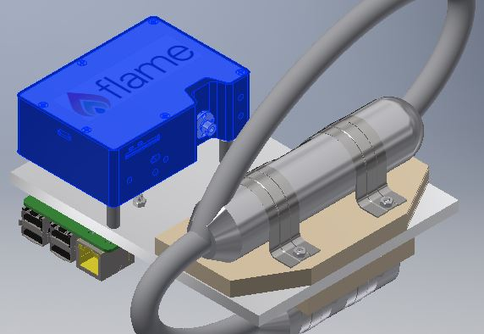

Step 3

Connect your cables to the Rasp Pi, Ocean Optics Flame and the Transformer

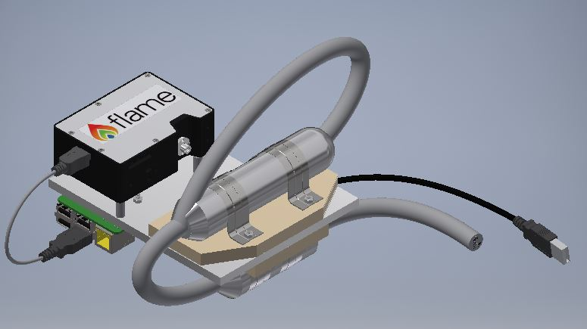

Part VII

Shop Drawings

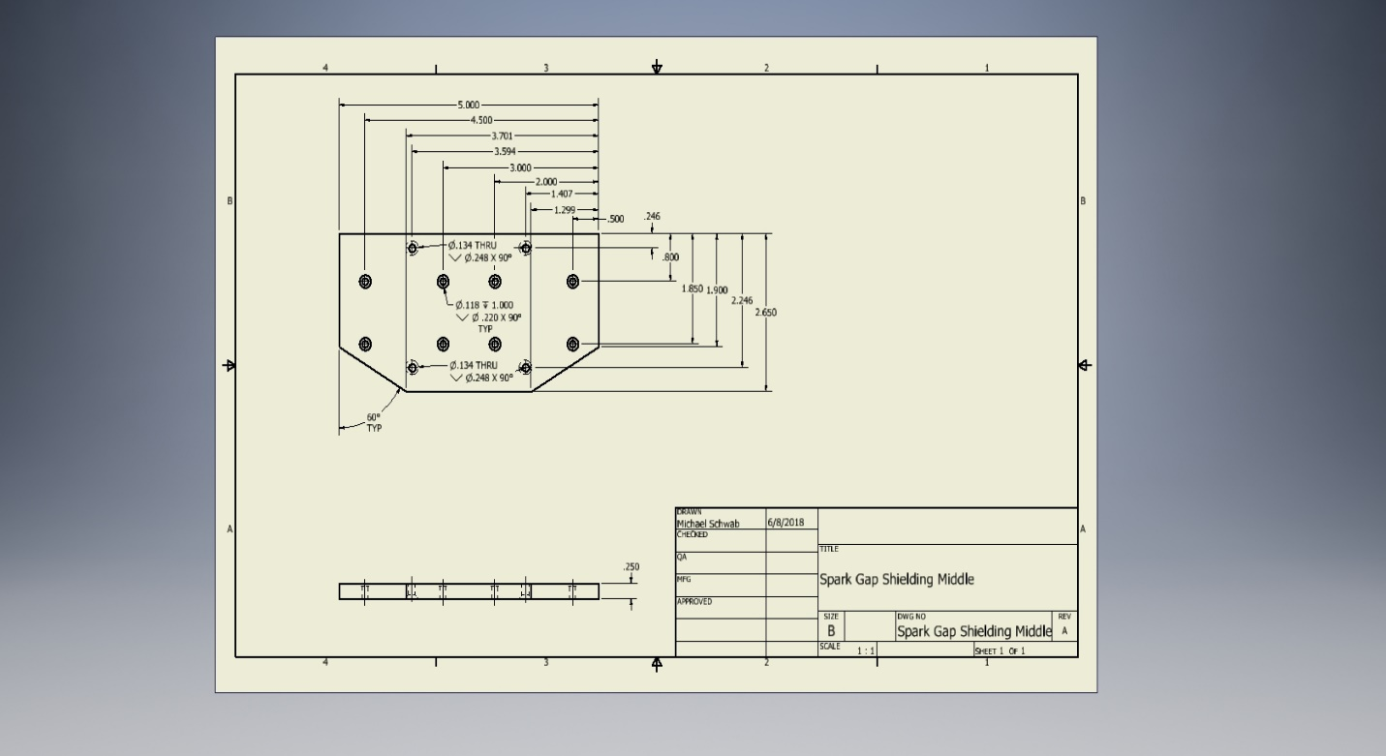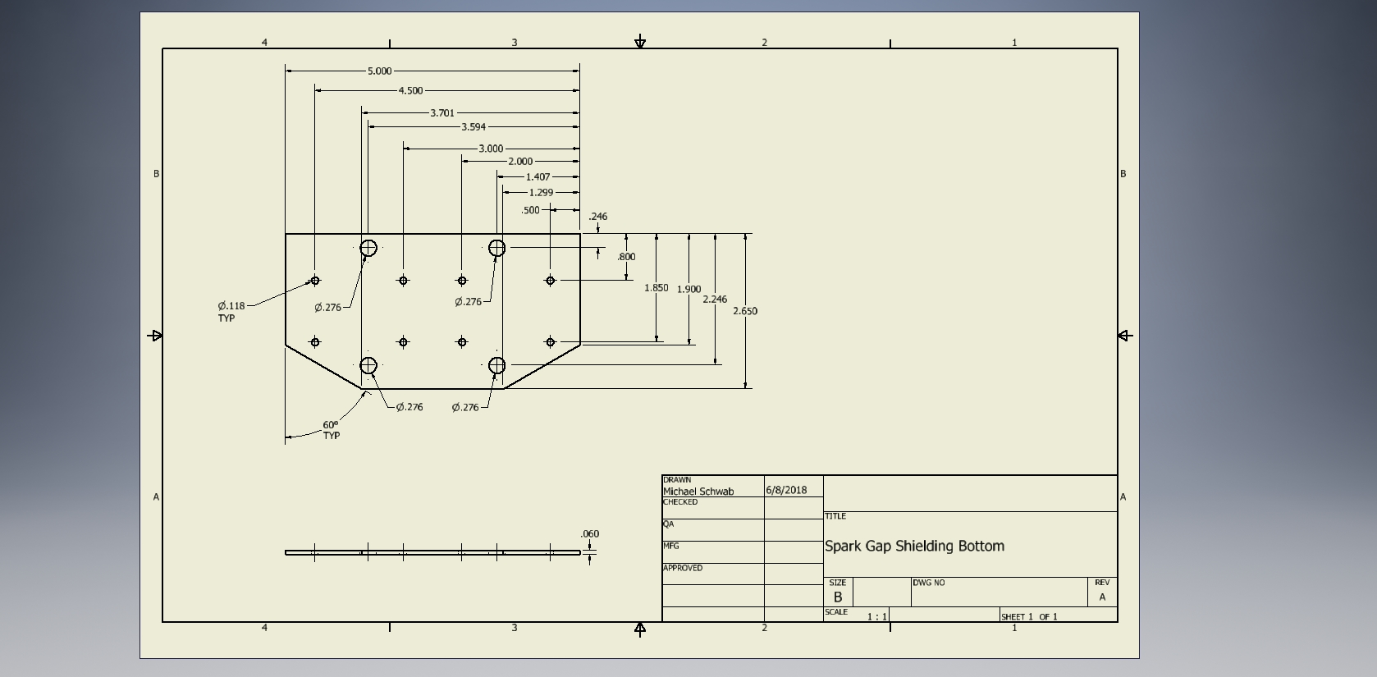 **Spark Gap Shieldings**

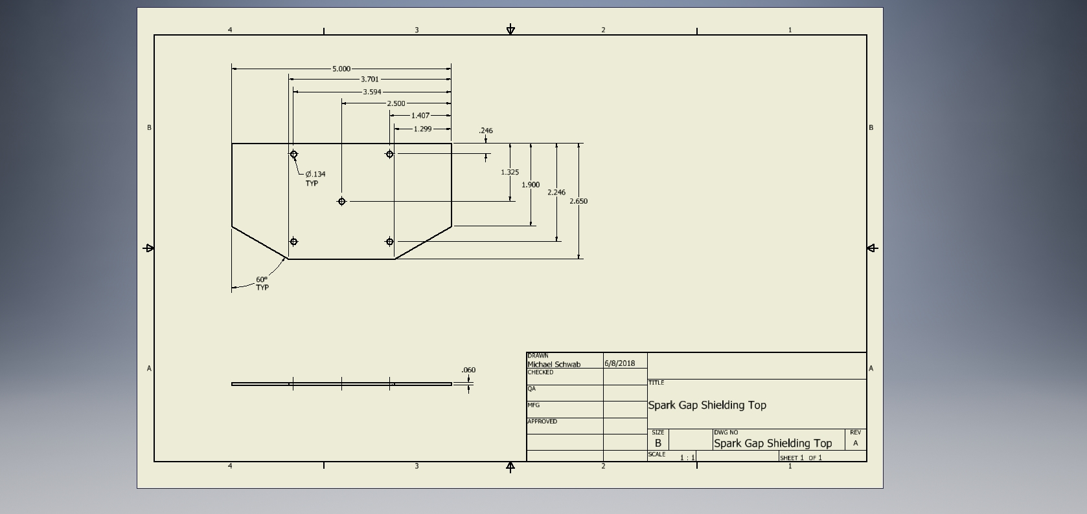

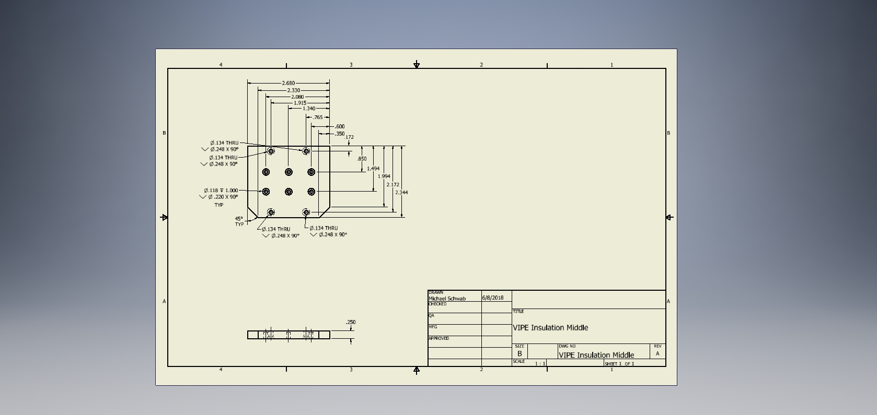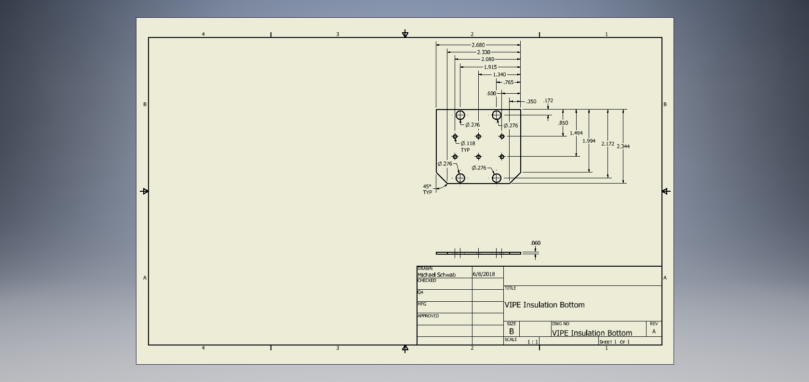**VIPE Insulation**

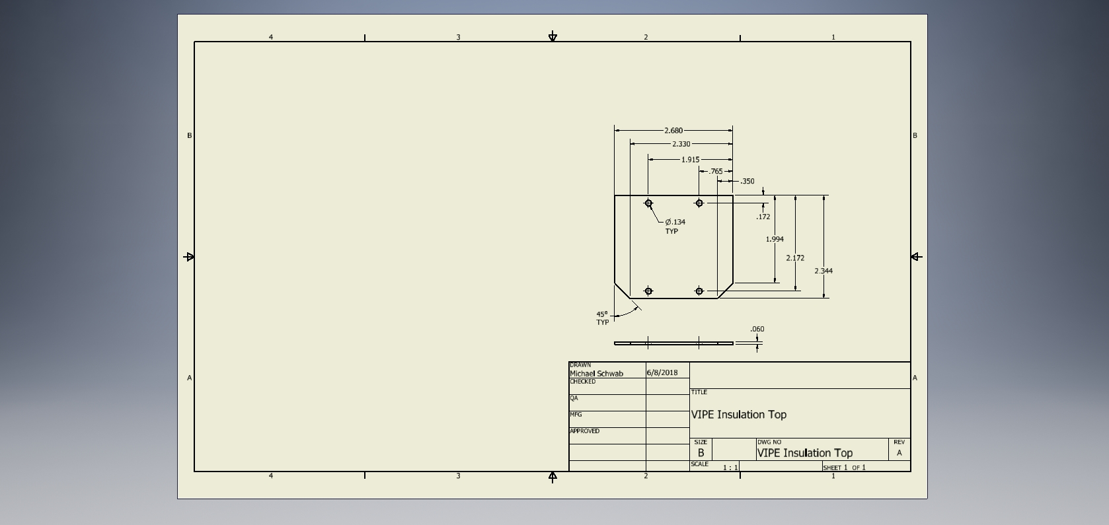

Part VIII

Manufacturing

|  |  |  |  |
| --- | --- | --- | --- |
| **Parts** | **Tools Used** | **Method** | **Notes** |
| Electrode Holders | * Drill Press | * Suggested method: insert Delrin rod in baffle. To sand, connect Delrin rod in drill press and spin the baffle | * Manufactured at UMBC * Due to quartz tube not uniformed, baffles need to be sanded |
| Standoffs (for Pi) | * Saw * Drill Press | * Use saw to cut length * Use drill press to cut the hole for the screw | * Delrin Piece ordered from McMaster * Screw diameter = 0.086" |
| Base Plate | * Milling Machine | * Manual milling or CNC |  |
| G10 | * Laser Cutter | * Machine it or laser cut, depending on thickness | * Used 3 smaller laser cut sheets made by hand |
| Viton for transformer | * X-ACTO knife | * Cut with X-ACTO knife |  |
| Electrodes for Spark Gap | * Machined |  | * Manufactured at UMBC |
| Wire Mesh | * Tin snips | * Compress to size of transformer to increase the diameter and decrease the length.   (Do this before cutting for better length results) | * Wear Gloves. (will give you metal splinters) |
| Clamps | * Vice * Drill Press * Hacksaw | * There are ridges on both ends of the clamps. Take the vice and crush it down to make it flat. Once it is flat, position it on the already cut G10 and mark where the holes need to be to bolt on the G10. Then use the drill to cut 5/32 inch holes. | * Take a hacksaw and cut of the excess. |